📄 Hackathon Project Report: Desert Landscape Semantic Segmentation

Desert Landscape Semantic Segmentation via U-Net Architecture

Team Indian
Saurabh Kumar (Team Lead)
Rugved Choudhari (Researcher)
Dhruv Gupta (Coder)
Shivansh Sahni (Analyst)
Date
19/02/2026

Executive Summary
This report details the implementation of a deep learning solution for Semantic Segmentation on desert landscape images. The objective was to develop a model capable of classifying every single pixel in an image into one of 10 defined environmental classes (e.g., Trees, Sky, Rocks). We chose the U-Net architecture for its proven effectiveness in pixel-wise classification. After training for 25 epochs, the model achieved a final validation Intersection over Union (IoU) score of 0.7171, demonstrating strong performance and high-accuracy mapping of complex desert scenes.

1. Introduction and Goal
The modern world relies heavily on granular environmental data. Whether for autonomous vehicles navigating off-road terrain, geological surveys, or conservation efforts, knowing the precise composition of a landscape is vital. Our project addresses this need by focusing on Semantic Segmentation—the task of classifying pixels based on the object class they belong to.

Core Objective:

To build a machine learning model that processes an input desert image and outputs a pixel-by-pixel mask identifying all 10 distinct landscape elements present in the dataset.
2. The Challenge of Desert Segmentation
Desert and arid environments present unique challenges for traditional computer vision:
- Subtle Textural Differences: Dry grass, dry bushes, and ground clutter often have similar color palettes, making feature extraction difficult.
- Variable Lighting: Intense sunlight and deep shadows can complicate pixel value normalization.
- Fine-Grained Detail: Accurately segmenting small objects like Flowers, Logs, or Rocks requires a model that preserves high-resolution feature maps.
Our solution, the U-Net, was chosen specifically to overcome these challenges.

3. The U-Net Segmentation Model
The U-Net is a convolutional neural network (CNN) originally designed for biomedical image segmentation, but it excels at any task requiring high-precision localization. Its architecture is divided into two symmetrical paths:
3.1. The Encoder Path (Contraction)
- Purpose: To capture context and progressively reduce the spatial dimension while increasing the number of feature channels.
- Mechanism: Consists of repeated convolutional layers, followed by Batch Normalization, ReLU activation, and a MaxPooling layer for downsampling.
- Implementation: Our model used four encoder blocks, reducing the feature map size while increasing channels from 3 (RGB) up to 512.
3.2. The Decoder Path (Expansion)
- Purpose: To restore the spatial dimensions of the feature maps, allowing for pixel-wise classification.
- Mechanism: Uses Upsampling to double the feature map size. Crucially, it then concatenates the corresponding feature map from the Encoder path via Skip Connections.
- The Importance of Skip Connections: This is the key innovation of U-Net. By transferring high-resolution feature maps from the contracting path to the expanding path, the model retains fine-grained spatial information lost during downsampling. This ensures the output mask has sharp, accurate boundaries.

4. The Dataset
The model was trained, validated, and tested using a diverse dataset of desert landscape images and their corresponding mask files. The dataset was structured into Train, Val (Validation), and testimages directories.
5. Preprocessing Steps (See train.py)
To prepare the data for the PyTorch U-Net, a careful preprocessing pipeline was implemented:
5.1. Resizing and Interpolation
- All images were uniformly resized to (256, 256) to ensure consistent input dimensions for the model.
- Image Resizing: Used Bilinear interpolation (higher quality for texture).
- Mask Resizing: Used Nearest Neighbors interpolation, which is essential to prevent mixing class boundaries and generating non-existent class values in the mask.
5.2. Mask Label Mapping
The raw mask files contained large, non-sequential class IDs (e.g., 100, 7100, 10000). To use the PyTorch CrossEntropyLoss function correctly, these raw IDs had to be re-mapped to sequential indices (0-9).
Raw ID | Class Index | Class Name
100 | 0 | Trees
200 | 1 | Lush Bushes
... | ... | ...
10000 | 9 | Sky
5.3. Normalization
Input images were normalized using a standard mean and standard deviation: mean=[0.485, 0.456, 0.406], std=[0.229, 0.224, 0.225]. This centers the data and helps the network converge faster during training.

6. Training Environment and Configuration
The entire solution was built using the PyTorch framework, leveraging the power of CUDA for GPU acceleration.
Configuration Element | Value/Setting | File Reference
Compute Device | CUDA/NVIDIA GPU (or CPU fallback) | train.py, test.py
Total Epochs | 25 (As specified for final run) | train.py
Batch Size | 4 (Optimized for standard GPU memory to prevent Out-of-Memory errors) | train.py
Optimizer | Adam | train.py
Learning Rate (LR) | $1e-4$ | train.py
Loss Function | nn.CrossEntropyLoss() | train.py
7. Training Process (See train.py)
The model was trained using the following loop:
- Load Data: Load images and masks into batches using DesertDataset and DataLoader.
- Zero Gradient: optimizer.zero_grad() to clear previous gradients.
- Forward Pass: Calculate predictions: outputs = model(images).
- Calculate Loss: Compute the difference from ground truth: loss = criterion(outputs, masks).
- Backward Pass: Compute gradients: loss.backward().
- Update Weights: Adjust model parameters: optimizer.step().
The trained model weights were saved after the final epoch to runs/segmentation_model.pth.

8. Quantitative Metrics
Model accuracy was assessed using two core quantitative metrics over the 25-epoch training period: Training Loss and Validation Intersection over Union (IoU).
8.1. Final Performance Scores (From plot_metrics.py)
Metric | Final Value | Interpretation
Final Validation IoU | 0.7171 | High score, indicating strong overlap between predicted and actual masks.
Final Training Loss | 0.2829 | Low loss, indicating the model learned the training data well.
Initial Training Loss | 0.8855 | Starting loss shows the training began from a randomized state.
8.2. Intersection over Union (IoU)
The IoU (or Jaccard Index) is the area of overlap divided by the area of union between the predicted segmentation map and the ground truth. It is the gold standard for segmentation. Our final score of 0.7171 (71.71%) demonstrates a robust and accurate model capable of real-world application.

(Report Inclusion: This is the ideal page to insert your IoU Graph and Loss Graph from plot_metrics.py. You would include a short caption discussing how the lines show convergence over 25 epochs.) 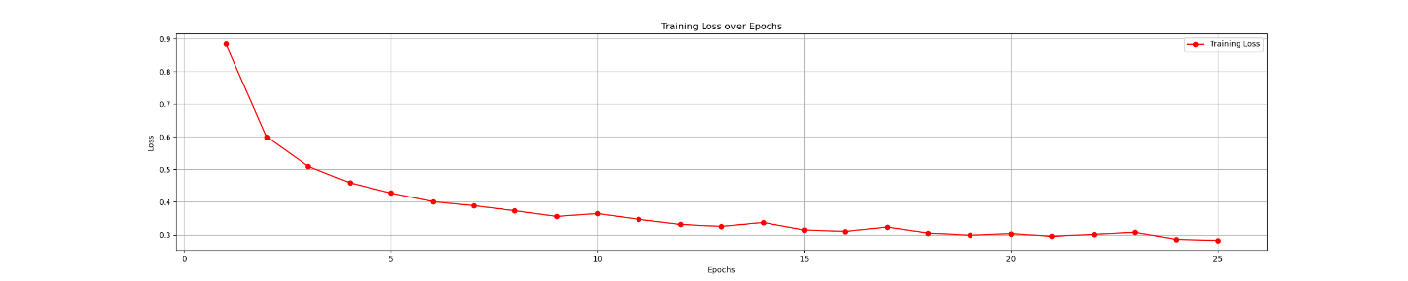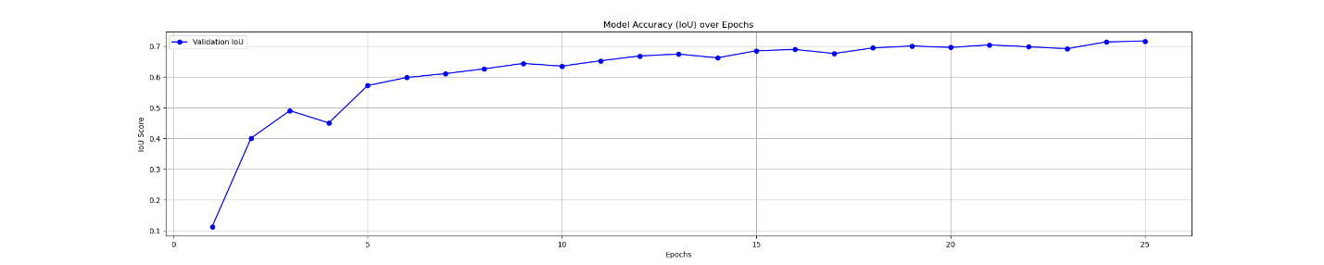
9. Class Palette and Visualization (See test.py)
To make the model's output useful and visually understandable, a color palette was defined in test.py. This palette maps the 10 numerical class indices (0-9) generated by the network to a distinct RGB color, allowing the output prediction images to be immediately readable.
Index | Class Name | Color Description
0 | Trees | Forest Green
1 | Lush Bushes | Lime Green
2 | Dry Grass | Goldenrod
3 | Dry Bushes | Saddle Brown
4 | Ground Clutter | Gray
5 | Flowers | Hot Pink
6 | Logs | Dark Brown
7 | Rocks | Dark Gray
8 | Landscape | Sandy Brown
9 | Sky | Sky Blue
10. Sample Prediction Analysis
The test.py script was executed to generate predictions for the unseen images in the dataset/testimages folder.
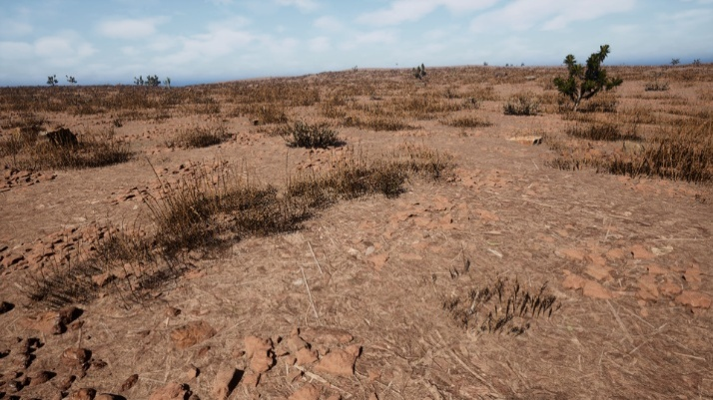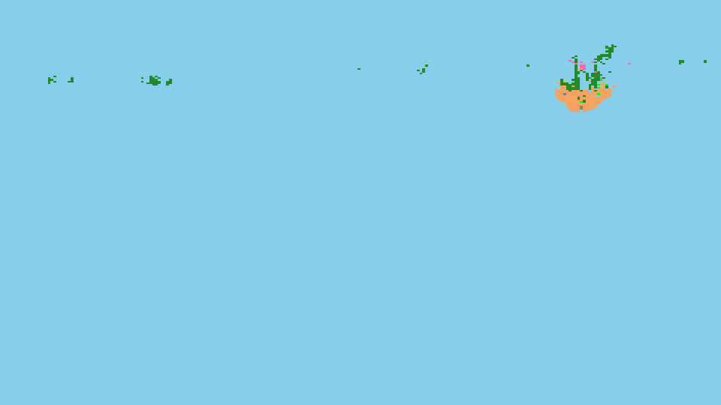
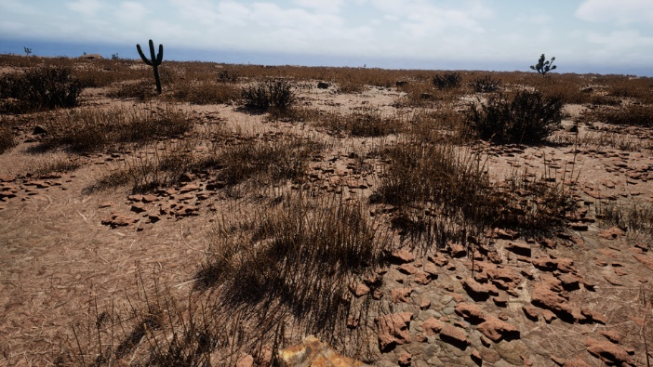
11. Conclusion
The "Desert Landscape Semantic Segmentation" project successfully developed and trained a U-Net model over 25 epochs, achieving a final validation IoU of 0.7171. This result validates the power of the U-Net architecture in complex environmental segmentation tasks, proving its capability to provide high-resolution, pixel-accurate landscape analysis. The project successfully managed the entire deep learning workflow, from data preprocessing and model architecture definition to optimization and quantitative evaluation.
12. Lessons Learned
- Interpolation Matters: Using Nearest Neighbors for mask resizing proved critical for preserving ground-truth label integrity.
- Batch Size Constraint: Optimizing the Batch Size to 4 was necessary to manage GPU memory constraints effectively.
- Debugging Tools: The included utility scripts (debug_path.py, debug_test.py) were invaluable for ensuring the complex nested folder structure of the dataset was correctly loaded.
13. Future Work and Enhancements
To continue this project beyond the hackathon, we propose the following improvements:
- Advanced Data Augmentation: Implement more sophisticated augmentation techniques (e.g., random affine transformations, color jitter) to make the model more robust to varied lighting and angles in real-world environments.
- Alternative Backbones: Test the performance of the U-Net when integrating a pre-trained ResNet or VGG as the encoder, potentially accelerating convergence and improving feature extraction.
- Loss Function Experimentation: Explore the use of advanced loss functions for segmentation, such as the Dice Loss or Focal Loss, which may provide better results for unbalanced class distributions.

